Summer Newsletter
Wisconsin WIC Association (WWA) 2017

SAVE THE DATE

September 29
2017 WWA’s Professional Development Day
Oshkosh, WI

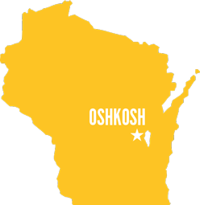

WWA Membership Winner Announced!
The region with the highest percentage of project membership and winner of $100 incentive is… (drumroll please)
Southeastern Region!
Congratulations!
To read about WWA membership benefits, visit our webpage at: www.wiwica.org/membership.aspx.

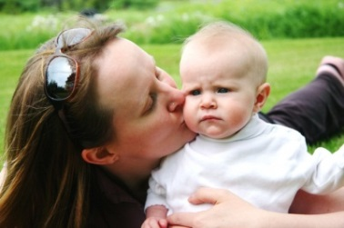
Dear WWA Member
We started off the month of April celebrating Public Health Week. As the nation’s premier public health nutrition program, WIC is a cost-effective, sound investment—insuring the health of our children. For over 40 years, WIC has been effective in reducing the burden of these public health problems for millions of families and the general population.
We are thankful to all who participated in promoting WIC during Public Health Week via social media, open houses and other formats. As a reminder you can visit our website for materials that help support you in educating stakeholders about our wonderful program throughout the year: (www.wiwica.org).
Thank you,
Your Friends at WI WIC Association

Voices of WIC
“Thank you for improving day after day. God bless you always.”
“…thank you for caring about us”,
“Every day even better, great, thank you to all”
Comments from families regarding expansion of late hours, Sixteenth St. (translated)

WWA Representatives attend National WIC Leadership Conference
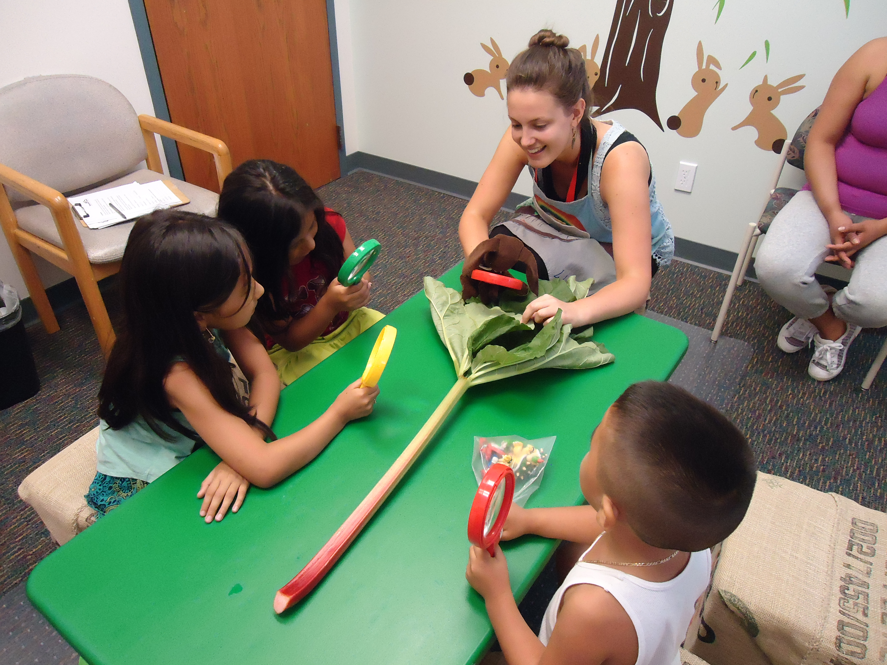
2017 WWA Board
Officers
Chair: Abbie Loos
Vice-Chair: Angela Roltgen
Secretary: Katy Murphy
Treasurer: Barbara Sheldon
Regional Representatives:
Southern Region:
Angela Roltgen
Portage County
roltgena@co.portage.wi.us

Western Region:
Jennifer Loging
La Crosse County
jloging@lacrossecounty.org

Northern Region:
Vacant

Southeast Region:
Katy Murphy
Sixteenth Street Community Health Centers
Katy.Murphy@sschc.org

Northeast Region:
Barbara Sheldon
Winnebago County
bsheldon@co.winnebago.wi.us

At Large Representatives:

Rosamaria Martinez
Sixteenth Street Community Health Centers Rosamaria.Martinez@sschc.org

Tiffany Halama
Wood County
thalama@co.wood.wi.us

Angie Wilks-Tate
MLK Heritage Health Center
awilks_tate@mshi.org

Abbie Loos
La Crosse County
ALoos@lacrossecounty.org

Becky Litwaitis
City of West Allis Health Department
BLitwaitis@westalliswi.gov

Lindsey Brost
Rusk County WIC lbrost@ruskcountywi.us

The annual National WIC Association (NWA) Leadership Conference 2017: Lifting Up Your WIC Voice, was held in Washington D.C., February 26 – February 28. Attendees were:

1. Jennifer Loging, La Crosse County WIC

2. Brandon Rohrig, Bay Area WIC

3. Lindsey Brost, Rusk County

4. Angela Sanfelippo, Sixteenth Street WIC, Milwaukee

5. Natalie Alcaraz, City of Milwaukee

6. Cheryl Davies, City of West Allis

7. Calli Bemis, City of West Allis

All attendees benefited from the conference, including the educational sessions and the visits to Capitol Hill to meet with legislators. Sharing and learning from WIC Programs in different states was a highlight of the breakout sessions. The conference also provides training and resources to prepare conference attendees to meet with legislators to advocate for WIC.

Key Messages for the 2017 conference:

• WIC has strong bipartisan support

• WIC adds value and provides a solid return on investment

• WIC is a short-term program with long-term benefits

• WIC supports military families.

Additional information on these Key Messages as well as Talking Points can be found on the NWA Website.

The team from Wisconsin divided into groups for visiting different offices. Between everyone, national and Wisconsin specific WIC information was shared in the offices of Jim Sensenbrenner, Sean Duffy, Ron Johnson, Tammy Baldwin, Ron Kind, and Gwen Moore. Thank you to those who attended!
