Your WIC Voice Tool Kit
No one knows WIC as well as WIC staff! That knowledge and experience present you and your colleagues with the unique opportunity to be a Voice for WIC. The National WIC Association has an online tool kit to walk you through a variety of advocacy activities with tips, worksheets, and examples of how you can elevate Your WIC Voice. Find the tool kit on nwica.org.
Who is the National WIC Association and how can we help?
NWA is the non-profit education arm and advocacy voice of the Special Supplemental Nutrition Program for Women, Infants and Children (WIC). Agencies are the front lines of WIC’s public health nutrition services for the nation’s nutritionally at-risk mothers and young children.
Who is the Wisconsin WIC Association?
The mission of WWA is to inspire and empower the Wisconsin WIC community to advocate for and promote quality nutrition services and assure effectiveness through collaboration, cooperation, and education.
Web: http://wiwica.org/
Facebook: Wisconsin WIC Association

In this tool kit you will find:
- Why Education Matters! Information about why it’s important to talk about WIC on a local, state and national level.
- Advocacy vs Lobbying – What are they? How are they different?
- Funding Basics – A quick explanation of how WIC is funded.
- How to Engage Partners – Strength in Numbers!
- Key Messages – Important messages for 2016 and every year along with tips for how to tailor messages and talking points.
- Talking Points – Important points to support our 2016 Key Messages.
- Developing Your Messages – A worksheet to help you develop messages about WIC for policymakers, the media, or community groups about WIC.
- Contacting Elected Officials – Now that you’ve got your talking point created, here are some tips for contacting policymakers.
- Something Bad Happened! At some point, you will probably need to respond to something negative, here is some advice.
- Talking to the Media – Doing media interviews is a great way to raise Your WIC Voice. We’ve put together a few tips to help you prepare.
- How to Pitch a Story – Don’t just wait for the media to notice WIC, reach out and let them know what you’re up to!
- Writing an Op-Ed – Op-eds are a great way to reach more people. See our guide for writing and submitting.
- Templates and Examples of Press Releases and Op-eds.
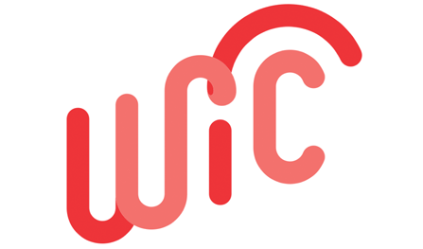
Adapted from the National WIC Association

