Key Messages
When speaking with members of Congress or to their staff, talking to the media, bringing up a WIC issues at a town hall meeting, or promoting WIC to the general public, NWA encourages you to incorporate some of these key messages into your advocacy communications. Consistently communicating these messages will help mitigate misconceptions about WIC and hopefully integrate them into the political discourse about WIC.
WIC: Strengthening families, strengthening communities, strengthening America.
WIC is grounded in science, efficiency, and compassion.
WIC: Prevention program with strong bipartisan support.

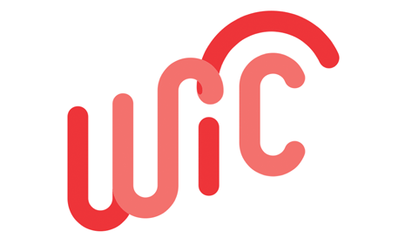
Adapted from then National WIC Association

Talking Points
WIC Strengthens Families
Four Pillars of WIC Service
- Healthy food
- Nutrition education
- Breastfeeding support
- Healthcare referrals
What does the participant take away from their experiences with each?

Positive Health Outcomes
Describe how the 4 pillars help families achieve positive outcomes:
Improved health behaviors
- Diets
- Breastfeeding rates
Improved health outcomes
- Birth outcomes
- Children arrive at school ready-to-learn
- Others
- Healthcare savings
Cutting participants from the program will have negative consequences.
Consult WIC for a Healthier America. The Role of WIC in Public Health, and other NWA Fast Sheets for more information.
WIC Strengthens Communities

Healthy children and families
Dollars spend in local economies
Minimum stocking requirements improve food access for all
WIC clinics are a trusted community resource and a gateway to other health and social services
Consult WIC for a Healthier America
WIC supports vulnerable populations at critical times of growth and development
WIC Strengthens America
Kids come to school ready-to-learn with the opportunity to reach their potential
WIC helps address national public health concerns, such as obesity
Fewer nutrition-related illnesses and low birth weight babies save health care costs
Healthier children and healthier adults mean more productive workforce
WIC supports active military families
Consult WIC for a Healthier American and WIC State Profiles
WIC is grounded in science, efficiency, and compassion
- WIC food package undergoes rigorous scientific review every 10 years to meet the specific nutritional needs of mothers and children
- Over 40 years of science-based nutrition has contributed to improved health outcomes
- Efficient management
- Effective service delivery
- Entrepreneurial
  - Dollars spent in local economies
  - Cost containment
  - Creative use of limited resources
- Cuts would impact core program components and undermine essential outcomes
- Trained professionals and paraprofessional WIC staff provide tailored support to families
- Tell a personal story about how WIC helps families through compassionate in-clinic care
- Consult WIC for a Healthier American and WIC State Profiles
WIC has strong bipartisan support
Historically bi-partisan supported and championed
Admired across political, ideological, ethnic, and socio-economic groups, and voters overwhelmingly oppose cutting funding for WIC
Clients are thankful for the program
Consult NWA Public Opinion Poll Brief and client testimonials

Developing Your Personal Messages
What is your role in the WIC Program?
__________________________________
Given your role and experience, which talking points can you speak most to?
___________________________________________________________________________________________________________________________________________________________
Write down some of the national, state, and local level statistics to support your talking points. Consult your state profile for some state level statistics.
____________________________________________________________________________________________________________________________________________________________
Think about any personal stories from your own experience, participants, and other colleagues about how WIC has strengthened families, is efficient/effective/entrepreneurial or is well-liked.
____________________________________________________________________________________________________________________________________________________________
Now that you have thought about those experiences, list those you can contact to use in your advocacy efforts.
EX: Working mom breastfeeds at home with support from employer, WIC Program.
________________________________________________________________________________________________________________________________________________________________________________________________________________________________________________________________________________________________________________________________________________________________________________________________________________________________________________________________________________________________________________________________________________________________________________________________________________________________________________

Tailoring Your Message
Local Representatives
National Representatives
Who is your Senator? Party affiliation?
______________________________ ______________________________
Who is your Senator? Party affiliation?
______________________________ ______________________________
Who is your Congressman/woman? Party affiliation?
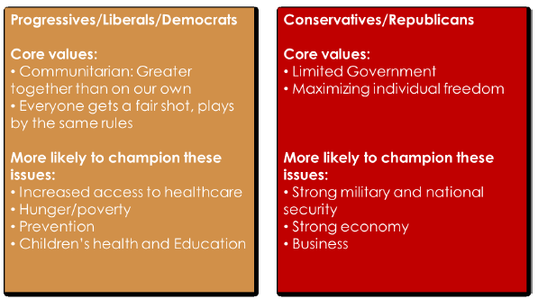
______________________________ ______________________________

What issues are your Members of Congress most interested in?
____________________________________________________________________________________________________________________________________________________________________________________________________________________________________________________________________________________________________________________________________________________________________________________________________________________________________________________________________________________

How would you frame your personalized messages to your elected officials?
__________________________________________________________________________________________________________________________________________________________________________________________________________________________________________________________________________________________________________________________________________________________________________________________________________________________________________________________________________________________________________________________________________________________________________________________________________________________________________________________________________________________________________________________________________________________________________________________________________________________________________________________________________________________

Plan Your Advocacy Outreach
Now that we have expanded your knowledge on WWA advocacy, we need you to use it, as well as the tools, to plan your own event.
- Complete questions in Key Message handout
- Choose what type of event you will be having
  - Open house, media blitz, WIC Family Appreciation Day, etc.
- Choose a day for your advocacy outreach event
- Promotion of advocacy outreach event
  - Newspapers, social media, webpages, TV/radio
- Use any of the tools provided to aid in your event
  - Your WIC Voice Tool Kit
  - Key Messages
  - WWA Advocacy Powerpoint
  - NWA website
  - WWA website
- Host advocacy outreach event
When addressing the public through social media, use one or all of the following hashtags:
#WICworks #wiWIC

