WWA Advocacy Ideas:
- Advocacy Lunch and Learns
  - Schedule a time to talk about current issues/educating/describing advocacy activities with staff using the PowerPoint in the WWA Advocacy Toolkit.
- Write Social Media Posts/pictures, snapchat filters, advocacy speech bubbles
  - Have a contest on social media (like Facebook) to see who gets the most likes, or had out incentives to participants for liking your Facebook page.
- Talk about policy updates from NWA
  - Schedule a time to regularly update staff on current issues and information that is relevant to WIC.
- Mail packets to your legislators
  - Develop a cover letter describing the benefits of WIC (using the guidance document) and give state or project specific information/statistics.
  - Find your state’s fact sheet here, or use WWA “Impact of WIC” document to tailor to your project’s numbers:
    - www.nwica.org/wic-basics#row-states
- Submit an op-ed
  - Use the example “Op-Ed Template” in the WWA Toolkit to submit an op-ed to local newsletters or news reporting stations/websites to increase awareness and education about WIC and the community we serve. Feel free to tailor to include personal or project specific information.
- Advocacy Quiz with staff
  - Have staff complete the advocacy quiz (sample below) to increase their knowledge of advocating for WIC. Give an incentive to those who get questions right to increase participation!
- Button design contest
  - Have each staff member develop a design to put on a button using wackybuttons.com or other websites available. Have them vote on the best design(s) and order the buttons for them to wear year-round. You can even design buttons to hand out to participants! Here are some examples:
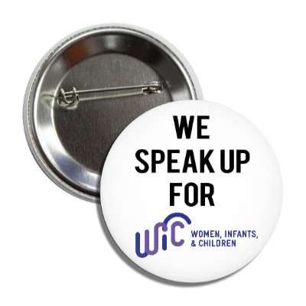
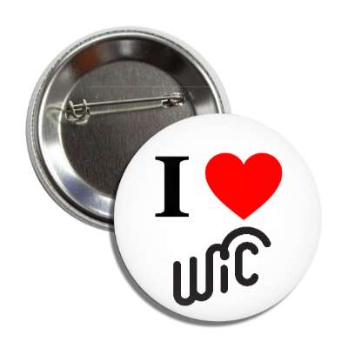

- Waiting room poster or bulletin board
  - Design a poster/bulletin board to display in WIC waiting rooms or clinic rooms that highlight WIC accomplishments or personal stories from some of your participants.
- Team up!
  - Contact a local organization or coalition that serves your community to educate or share stories about WIC and learn more about them to encourage awareness and participant recruitment. Attend one of their meetings or events to build a strong partnership.

Sample Advocacy Quiz for project staff:
Advocacy Quiz
- Name two good things about discussing the benefits of WIC with various stakeholders:
  - Improve participant recruitment
  - Encourage congress to enact policies and funding that support WIC
  - Increase public support of the program

- How are advocacy and lobbying different?
  - Advocacy is educating a person or group about a cause and naming benefits of supporting that cause.
  - Lobbying is asking a legislator to vote for/against a certain policy or trying to sway public opinion of the policy.

- What are WIC’s Four Service Pillars?
  - Healthy foods, nutrition education, breastfeeding support, health care referrals

- Describe how WIC is funded.
  - FNS meets to draft the WIC budget proposal, which is then reviewed and approved by the USDA. The draft is included in the President’s overall budget proposal and is voted on by Congress. Adjustments are made as the Appropriations Committee meet to allocate spending. The result of this meeting is the Agriculture Appropriations Bill, which must again be approved by Congress and the President before becoming a law.

- How would you look up the policy makers for your area? Who are they?
  - http://Maps.legis.wisconsin.gov

- Name three advocacy (non-lobbying) activities you could do at work.
  - Educating the public and members of Congress about WIC
  - Highlighting achievements of WIC in local media
  - Hosting events/open house that promote, celebrate, or inform about WIC
  - Invite a member of Congress to tour your project
  - Providing data on your local project
  - Describing personal stories or testimonies from your project
  - Describing the Breastfeeding Peer Counselor program and its importance
  - Explaining the benefits of EBT
  - Explaining how your clinic would respond to budget cuts

- For every dollar spent on a pregnant woman in WIC, up to $ is saved in Medicaid/BadgerCare costs for her and her newborn baby.
  - $1.77
  - $2.13
  - $3.13
  - $0.59

- What would you say to a mom whose children are on WIC and she calls to say she does not want to receive benefits anymore? What questions would you ask?

